Web Parts

- HTML → Content
- CSS → Design
- JavaScript → Behaviour
- React → Advance Web.

Installation

- Visual Studio Code (VSCode) → https://code.visualstudio.com/
- Live Server

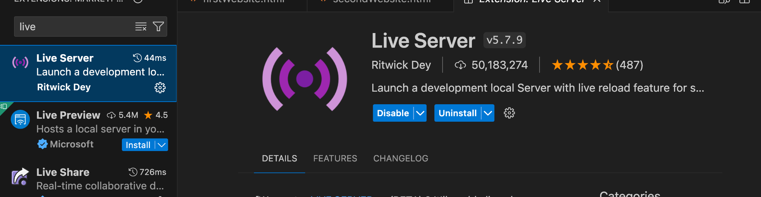

Tags

Tags are some special piece of information that helps to create content on websites.
And it gives a special meaning to our text.

Rule → 1. <TagName> Content </TagName>
2. <TagName />

Headings
- H1 —> <h1>Introduction</h1>
From h1 to h6
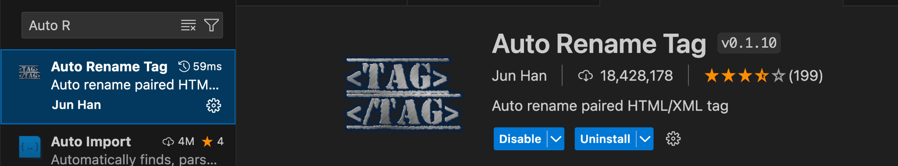

Paragraph (p tag): <p> Para </p>

Web Architecture

<!DocType html> → to tell the browser that I am going to render an HTML file on you.

<html>
<head></head> → Everything that is not content
<body> → Everything that is content
Tags

</body>

</html>

Tag Types

<h1 />

- Image → <img src = “pic” alt = “ALternate Text” />
- Links → <a href = “link” > Content </a>
- Lists → There are two types of Lists.
    - Ordered → ol
    - Un-Ordered → ul
    - List Item → li

Nested tags

Tags within Tags.

Comments → <!-- --> (no effect on web site)

Inputs Tag
One liner Data Entry in our website.
<input type = “text” />

Text Area
Multi-line data entry

<textArea> </textArea>

Projects
- Tribute Page.
- Product Website

CSS
The way we apply it by making a separate CSS file and then linking it with the HTML file.

Link Tag —>

Selector {
Property: value;
}

Selector —> Element that you want to style.
Property → Style you want to apply.
Value → which style value you wanna give.

h2 {
color: red;
}

H2 → Selector
Color → Property
red → value.

Types of Selectors

- Tag Selector → Choosing individual tags.

- Class Selector → Choosing specific elements from HTML

- ID Selector → Choosing specific elements from HTML

- Group Selector → Making groups

- Universal Selector —> Choosing (*)

- Attribute Selector → choosing element based on its attribute.

Colors

- By Name
- By RGB

R → Red → 0-255
G → Green → 0-255
B → Blue → 0-255

12, 200, 189

Color: rgb(red, green, blue)

- By Hex Value
10 -> A
11 -> B

6 digits. —-> (0-9) (A-F)

Color: #3B81D4

Typography

Everything related to Text.

Types of Tags

- Block Level
Tag took the whole space of screen from left end to right end. And did not allow any tag to come in front of him.

- Inline Level
Only took its space.

background-image: url("https://encrypted-tbn0.gstatic.com/images?q=tbn:ANd9GcQXyPHwlDUfIixfVtIMXl6CsG4KGSyoa3EvIA&s");
background-position: center;
background-size: cover;
background-repeat: no-repeat;

Box Model

- Apply border.

Border: width style co
Lor.

Padding : one value → All Side
Padding: two values ⇒ 1st (top & bottom) & 2nd (left & right)
Padding-left, padding-right

Layouts
We have two kind of methods to implement layouts.
- Flexbox
- Grid System

2 (X- Asix) (Y-Axis)

X-Asixx → justify-content:
Y-asix → align-items:

https://flexboxfroggy.com/

Animation
- Put a timer. (specify your time)

Animation = nameofAnimation 2s function.

- Animation?

0sec → right
2sec → Center

Website: https://animista.net/play/text

Icons: https://fontawesome.com/

Responsive Web Design

- Website and you have to do classes changes.

@media and all (max-width: 1200px){

}

Web Page Design
—----------------------------------------------------------------------------------------------

Phase 1 → Freelancing
Phase 2 →

https://10websites-design-to-html-css.netlify.app/

JavaScript

JS is a programming language.

To tell the computer to do something.

Rules & Syntax → We have to follow some certain things → Coding , Programming

print(“Allah”)
write(“Allah”)
writeDown(“Allah”)
output(“Allah”)

—---------------------------
console.log(“Value”)

3 Ways to define variables.
Let→ 2015 k bad
Var → 1991

Const → constant → once you put a value, it will never be .

You can change the values of your variables.

DataTypes

- Primitive → that can not be decomposed into others .
Int → numbers
  - String → Text
  - Boolean → True/False
  - Double → Decimal

Let age = 45.8;
- Object → that can be decomposed.

- Num = 30;
- “Talha”

Operators

- Some kind of mathematical or logical action. It’s a character and it applies to some values.

- → 2 + 4 ⇒ 6

- Arithmetic operators
+, -, *, /

- Relational Operators → comparisons
<, > , <=, >=, ===, !

- Write a Program which add ages of two brothers Talha & Ali.

- Logical Operators
- Relational Operators

Condtions
Let age = 12;

Talha can vote if he is 18 years old. Otherwise can not.
Talha can play if it is raining outside.
Talha can participate in games if he have BS degree.

Syntax:

If (condition){
// COde
}
Else{

// code
}

Condtions

< | Less than
> | Greater than
=== | Equal to
==! | Not equal to
<= | Less than and equal to
>= | Greater than and equal to

Let age = 20;

If ( age === 25){
console.log(‘User Cana);
}
Else{
console.log(‘User can not Vote’);
}

If else-if else

Let marks = 74;

90 → Excellent
80 → Good
70 → Not bad
60 → More effort required
Fail

If (marks > 90){
console.log(‘Excellent’)
}
else if (marks > 80){
console.log(‘Good’)
}
else if(marks > 70){
console.log(‘Not Bad);
}
else if (marks > 60){
console.log(More effort required);
}
else{
console.log(‘fail’)
}

I am donating biryani boxes. Writing a program to give 3 boxes above 40 years old, 3 boxes above 20, 2 boxes 15, and 1 box for rest.

I will play only if it is raining outside and other kids are playing and Mom will give me permission to play.

AND Operator (&&)
All should be true to get if result.

OR Operator (||)

If only one of the condition is true.

Loops

Loops are repetition.

It has 3 parts.

- Start
- End Condition
- Jump

Syntax

For (let start = 0; start < 10; start = start + 1){
console.log(“Talha”)
}

1 - 10

1 - 9

crash

Start = 0
Start = 1
Start = 2
Start = 3
Start = 4
Start = 5
…
..
..
Start = 10

Errors

- Syntax Error → Not following rules of language
- Runtime Error →
- Logical Error → Some Logical issue

Functions

Function FunctionName (){

// Body

}

- Input / Arguments / Parameter

Array

Problem: Too many variables are there.
Solution: store all same kind of data in one variable.

Let names = [ ‘talha’, ‘Ali’ , “Umar”, “Ikram”, “Irfan”, “John”, “Talha”............... ]

0, 1, 2, 3, 4, 5, 6

Array always starts from 0

- Similar kind of data. (collection)

Object → Real world

- Attributes → Properties
- Behavior → Function

Pair of a key = “value”.

Guidelines

- HTML → Content
- CSS → Style
- JS → Programming Core (variables, conditions, control flow, functions, arrays , objects)

- 3-5 problems
- Projects

Access
querySelector
- By Tag → tag should only be one.
- By Class → need a dot before name in querySelector
- By ID → HW

Change
- Content
  - innerHTML
  - textContent
- Attribute
  - setAttribute()
- Style/CSS
  - Direct style ⇒ element.style.padding = ‘value’
  - Css classes ⇒
    - name2El.classList.add(‘name’)
    - name2El.classList.remove(‘name’)

Events & Event Listeners

Event → The action or the interaction we will do on our website.

Event Listener → The Response to an event.

- Choose element on which event will occur.
- addEventListner to that element → addEventListener(type, function)

Type → Which type event?
Function → which function to execute?

TODO
- Intro
- Variables
- DataTypes
- If-Else
- Loops
- Functions
- Arrays
- Objects
- DOM

============================
Projects → Professional website → End Of WEB Dev Course

JavaScript Advance → Collaborate with other websites. → 5-10 days

React → Advance Frontend library. (insta, fb, uber, gmail, paypal, cream, spotify, netflix) -> 30 days

Node → Backend → 30 days

Projects

- Random Color generator
- Quote Generator
- Age Calculator

